Project Executable Files

Date | 28 September 2026
Team ID | SWTID-2026-1526
Project Name | AI StudyBuddy
Maximum Marks | 3 Marks

Project Executable Files
This section requires submission of all executable and deployable files for your project. Ensure all files are properly organized, named, and uploaded to the specified submission platform. The evaluator must be able to run or deploy your solution using the provided files and instructions.

Step 1: Submission Checklist

S.No | Item to Submit |  | Submitted  No / NA) | (Yes | /
1 | Complete source code (all files and folders) |  | Yes
2 | README / Setup Guide (instructions to run the project) |  | Yes
3 | requirements.txt / package.json / dependency file |  | Yes
4 | Database schema / seed files (if applicable) |  | Yes
5 | Environment configuration file (.env.example similar) | or | Yes
6 | Deployed application URL (if hosted) |  | Yes
7 | APK / Executable binary (if applicable for mobile/desktop apps) |  | Yes
8 | Dockerfile / Containerization config (if applicable) |  | Yes
9 | Test files and test results |  | Yes
10 | Demo video or walkthrough (if required) |  | Yes

Step 2: File / Folder Structure
Provide an overview of your project's file and folder structure below:
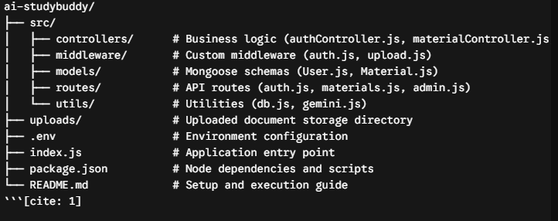

Step 3: Deployment / Access Details

Field | Details
Hosted / Deployed URL | Local Server (`http://localhost:5000`)[cite: 1, 19]
Login Credentials  (Demo) | Email:sai87@gmail.com  Password:sai567
Platform / Hosting  Provider | [e.g., Render, Vercel, AWS, Heroku, Azure]
Repository Link | https://github.com/Varalakshmi2025/AI-STUDYBUDDY
Demo Video Link | https://drive.google.com/file/d/1kz1TlfNe1vvIOZVTNodk8zolDrpqTcPE/view?usp=drivesdk

Step 4: Run Instructions
Provide clear, step-by-step instructions for the evaluator to run your project locally:

Pre-requisites: Node.js (v16+), npm, MongoDB, and a Google Gemini API Key[cite: 1, 19].
Step 1:Clone or download the repository source code[cite: 19]. Step 2: Open the project terminal and install dependencies: `npm install`[cite: 1, 19]. 3: Configure environment variables in a `.env` file (`PORT`, `MONGO_URI`, `JWT_SECRET`, `GEMINI_API_KEY`)[cite: 1, 19]. Step 4: Ensure MongoDB is running locally or via MongoDB Atlas[cite: 1, 19]. Step 5: Start the backend server: `npm start` (or `node index.js`)[cite: 1, 19]. *Step 6:Test endpoints using Postman or Thunder Client at `http://localhost:5000`[cite: 1, 19].

Step 5: Known Issues / Limitations

S.No | Known Issue / Limitation | Workaround / Status
1 | Large PDF files with scanned images cannot be text-parsed directly. | Users should upload text-based PDFs or .txt/.md files[cite: 1]
2 | Free tier Gemini API rate limits during heavy concurrent requests. | Implement request throttling or retry logic for production use[cite: 1]

